 |  | SE Convention ‘26 | Newsletter August 2025
 |  | Convention Friday 6th -7th February 2026
Venue- Reigate Manor Hotel  Entertainment  Friday DJ Max Saturday ABBA Magic  CNRO Updates  Add description text here to get your subscribers interested in your topic.  Your Convention Team  Phil Robinson – Chairman  Lynne Ireland- Deputy Chairman and Stall queen.  Jackie Robinson – Secretary and Sgt at Arms  David Burstow – Convention Accountant and Guru  Peter Li – Host committee Chairman |  | The Venue  Phil Robinson-Convention Team Chairman  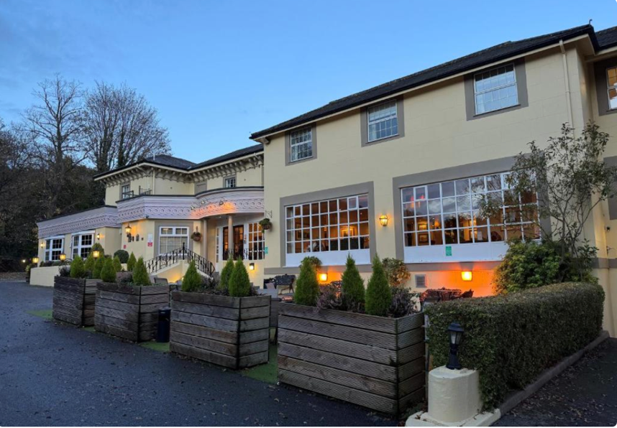  The Reigate Manor Hotel We are very pleased to confirm that we have booked an all under one roof Convention for 2026 at the Reigate Manor Hotel Reigate Surrey RH2 9PF  Reigate Manor Hotel Booking  Call: 01737 240125 State Ref 154603  Room Rates B&B £130 single £140 Double.  Food choice and Partners outing link will be available shortly on the convention website www.lions105se.uk

Entertaiment
  Saturday. ABBA Magic is a popular tribute band that aims to recreate the look, sound, and energy of the iconic Swedish pop group ABBA. They are known for their dazzling costumes, authentic vocals, and engaging stage presence, delivering performances of ABBA's greatest hits like "Dancing Queen," "Mamma Mia," and "Waterloo". ABBA Magic is one of the longest-established ABBA tribute acts in the UK, having been founded in 1994.      On Friday night we have the theme of Bollywood goes to Hawaii and we will dance the evening away with DJ Max. |  |  | CNRO Update  Phil Robinson-CNRO  Clubs will receive the official Convention call in early September and if you wish to propose a resolution or a nomination for 2nd Vice District Governor these should be with me by the 14th November.  Delegate and Alternate registration will open on the 1st October, and yes NIL returns are required please.  I would encourage any club considering a resolution to discuss it with me before you submit it, and of course if you are being nominated for 2VDG please contact me if you have any questions about the role.  I will put more timing information in Newsletter 2 nearer the time.  International Bookings  In the next edition of the Newsletter and on the Convention website www.lions105se.uk, will be a special link for any Lions booking from outside the UK. This includes Lions booking whilst on holiday.  This will be for Food choices, Convention Pin and Partners Outing. Room Bookings are direct with the hotel (see above)

