 |  | SE Convention ‘26 | Newsletter Oct 2025
 |  | Convention Friday 6th -7th February 2026
Venue- Reigate Manor Hotel  Entertainment  Friday DJ Max Saturday ABBA Magic  CNRO Updates  Add description text here to get your subscribers interested in your topic.  Your Convention Team  Phil Robinson – Chairman  Lynne Ireland- Deputy Chairman and Stall queen.  Jackie Robinson – Secretary and Sgt at Arms  David Burstow – Convention Accountant and Guru  Peter Li – Host committee Chairman |  | The Venue  Phil Robinson-Convention Team Chairman  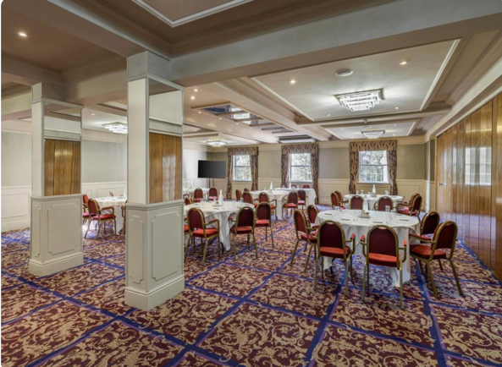  The Reigate Manor Hotel We are very pleased to confirm that we have booked an all under one roof Convention for 2026 at the Reigate Manor Hotel Reigate Surrey RH2 9PF- Plenty of Parking in site.  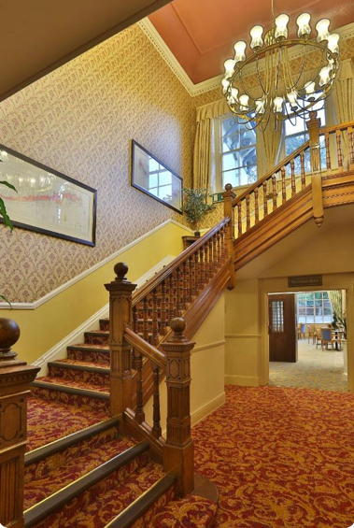  Reigate Manor Hotel Booking  Call: 01737 240125 State Ref 154603  Room Rates B&B £130 single £140 Double.  Menu choice and Delegate and Alternate Registration are now available on the convention website www.lions105se.uk

Special Guest
Endorsed Candidate for 3rd International Vice President  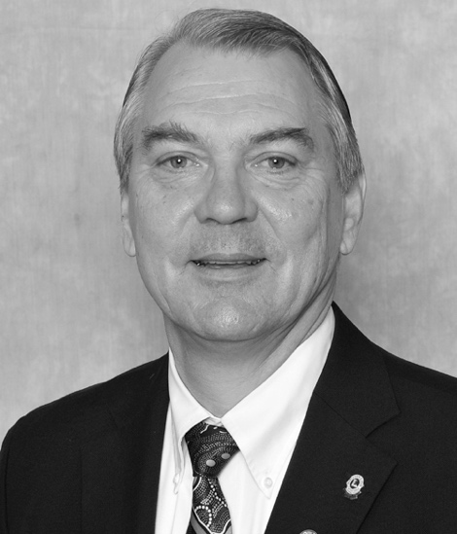  PID ROBERT RETTBY  Robert Rettby, from Neuchâtel, Switzerland, was elected to serve a two-year term as a director of Lions Clubs International at the association’s 96th International Convention held in Hamburg, Germany July 5 through 9, 2013. Past Director Rettby has a masters in civil engineering and was CEO and director of a group of family-owned construction companies. He has now retired from the company but is still professionally active as a consultant in the fields of water treatment and industrial safety. A member of the Neuchâtel Lions Club since 1993, he has held many offices within the association, including zone and region chairperson, district secretary, district governor and council chairperson. He is also chairperson and member of several national organizing committees, including LCI representative to UNICEF, Europa Forum president, Centennial Action Committee chairperson, DGE Seminar group leader and GST leader. In recognition of his service to the association, he has received numerous awards including five Presidential awards and the Ambassador of Good Will award. He is also a Progressive Melvin Jones Fellow. In addition to his Lions activities, Past Director Rettby has been active in numerous professional and community organizations, including the Committee of Energies of the City of Neuchatel, the Swiss Association of Architects and Engineers (SIA) and several other associations, circles and sports clubs. Past Director Rettby and his wife, Catherine, have two sons and two grandsons. |  | CNRO Update  Phil Robinson-CNRO  Reminder that nominations for 2nd Vice District Governor these should be with me by the 14th November.  Delegate and Alternate registration is open, and yes NIL returns are required please.  I would encourage any club considering a resolution to discuss it with me before you submit it, and of course if you are being nominated for 2VDG please contact me if you have any questions about the role.  International Bookings  In the next edition of the Newsletter and on the Convention website www.lions105se.uk, will be a special link for any Lions booking from outside the UK. This includes Lions booking whilst on holiday. – Now Live  Entertainment      Saturday. ABBA Magic is one of the longest-established ABBA tribute acts in the UK, having been founded in 1994.    On Friday night we have the theme of Bollywood goes to Hawaii and we will dance the evening away with DJ Max.

